Analysis of motion of a paradrop
Question 1
Motion of a paradrop can be categorized into two stages
The first stage (stage1) is where the parachute ha not opened up. Here motion is a free fall and the only factor affecting motion is gravity.
The equation of motion and free body diagram are given as follows:
$$s=\frac{1}{2}gt^{2}+v_{o}t+s_{0}$$

$$v(t)=gt+v_{o}$$
Where g is the gravitational acceleration g=9.81m/s^2
S is the altitude from which the paradrop is dropped
V is the velocity and t is time in seconds
Free body diagram

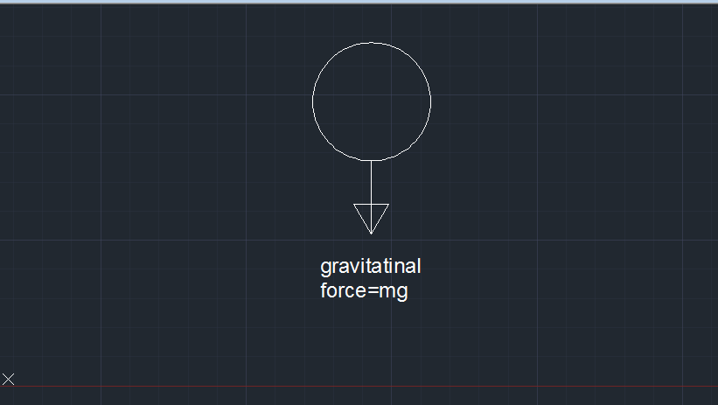
Stage2
In this stage the parachute opens up and the influence of air resistance in terms of drag force comes in .
The drag force is given by the following equation:
$$Fdrag=\frac{1}{2}ACd⍴v^{2}$$
Where, A is the area of the parachute in m, Cd is the drag coefficient while ⍴ is the density of air in kg/$m^{3}$.
The equation of motion is given as follows:
$$ma=mg-Fdrag$$

$$ma=mg-\frac{1}{2}ACd⍴v^{2}$$

Dividing with m on both sides:
$$a=g-\frac{\frac{1}{2}ACd⍴v^{2}}{m}$$

But
$$a=\frac{ⅆv}{ⅆt}$$
And let k= $\frac{1}{2}ACd⍴$ assuming the density of air is constant and the parachute is fully opened.
$$\frac{ⅆv}{ⅆt}=g-\frac{kv^{2}}{m}$$
The above equation can be expressed in this form:

$$\frac{ⅆv}{ⅆt}+\frac{kv^{2}}{m}=g$$

Which is a first order ODE.

The solution of the above equation is given as follows:
$$v\left(t\right)=\frac{mg}{k}(e^{-\frac{k}{m}t}-1)$$

$$s=\frac{1}{2}at^{2}+v_{o}t+s_{0}$$
Therefore:
$$s(t)=-\frac{1}{2}g(e^{-\frac{k}{m}t})t^{2}+\frac{mg}{k}\left(e^{-\frac{k}{m}t}-1\right)t+s_{0}$$
With the above equations are accurate only when the area is constant and the density of air doe not change with the altitude. However when the density of air comes in and the area is varying the following equation will be used:
Fdrag=$\frac{1}{2}Amax (\frac{t-tact}{tuff}) Cd ⍴o (1-10^-4s)v^{2}$
Where Amax is the maximum area
Tact is the time the parachute is activated
Tuff is the time the parachute takes to unfold.
Amax=50m^2
Tact=10s
Tuff =30s
$a= g-\frac{\frac{1}{2}Amax (\frac{t-tact}{tuff}) Cd ⍴o (1-10^-4s)v^{2}}{m}$

But $a=\frac{ⅆv}{ⅆt}$

Therefore the equation reduces to $\frac{ⅆv}{ⅆt}= g-\frac{\frac{1}{2}Amax (\frac{t-tact}{tuff}) Cd ⍴o (1-10^-4s)v^{2}}{m}$

After manipulation $\frac{ⅆv}{ⅆt}=$9.81$-$ [0.00616t$-0.$0616$-0$.616×10^-7st+6.16×10^-6s]$v^{2}$

Let $y=-$[0.00616t$-0.$0616$-0$.616×10^-7st+6.16×10^-6s]
The above equation reduces to $\frac{ⅆv}{ⅆt}=9.81-yv^{2}$
Which is a differential equation of first order. Therefore equation of motion of the second part (when the parachute starts to open) is a differential equation.

Free body diagram

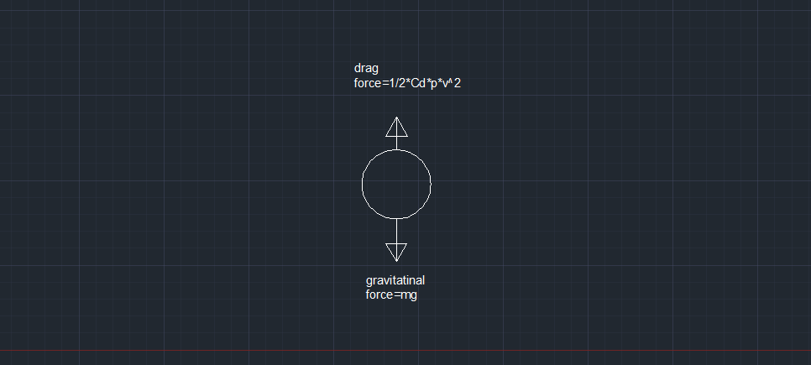

Question 2
The landing time and velocity when the parachute is not activated.
We use equation for stage 1 and solve them to get time and landing velocity if we know the altitude.

$$s=\frac{1}{2}gt^{2}+v_{o}t+s_{0}$$
$$0=\frac{1}{2}*9.81*t^{2}-1* t-3000$$
The above equation is quadratic. The solutions are as shown:
$t1=$24.83

$$t2=-24.63$$
Time cannot be negative therefore we take the positive part
$$t=24.83s$$
$$v(t)=gt+v_{o}$$

Using the first equation we can solve for the landing time

$$v_{o}=-1m/s^2$$
$$s_{0}=the altitude at which the parachute is launched$$
$$g=9.81m/s^2$$

Therefore
$$v(t)=9.812*24.83-1$$

$$v=242.5823$$

Question 3
The equations in the finite difference form can be written as shown below:
$$\frac{ⅆv}{ⅆt}+\frac{kv^{2}}{m}=g$$

$$\frac{v_{i+1}-v_{i}}{Δt}+\frac{k}{m}{(v}_{i})^2=g$$

The initial conditions is that v (0) =-1; s (0) =$3000$

However when air resistance is taken into consideration, the second stage of motion is governed by the following equation:
$\frac{ⅆv}{ⅆt}=9.81-yv^{2}$
This reduces to
$$\frac{v_{i+1}-v_{i}}{Δt}+y_{i}{\left(v_{i}\right)}^{2}=9.81$$

Therefore $v_{i+1}=v_{i}+ Δt(9.81-y_{i}{\left(v_{i}\right)}^{2})$

$y_{i}=[0.00616t -0.0616-0.616×10^-7st+6.16×10^-6s]$

Given that the number of nodes take are 20.
$$Δt=\frac{30-10}{20}=1$$
Before the unfolding of the parachute, the equation governing motion in finite difference form is as follows:
$$v_{i+1}=v_{i}+g* t$$

Question 4

The Matlab code for solving the finite difference equation is as follows:
N=10;
g=9.81;
m=80;
k=14.7875;
a=1;
b=m/k;
c=-g*m/k;

t=linspace(0,1,N+1);
t1=linspace(0,1,N-1);
dt=t(2)-t(1);
A=eye(N-1);
A=A*(k/m-1/dt)
A=A+1/dt*diag(ones(N-2,1),1)

v=((A)^-1)*(M)
plot(t1,v)
xlabel('time')
ylabel('velocity')

Plot of velocity against time is as follows:

Velocity increases up to maximum value which is the terminal velocity.

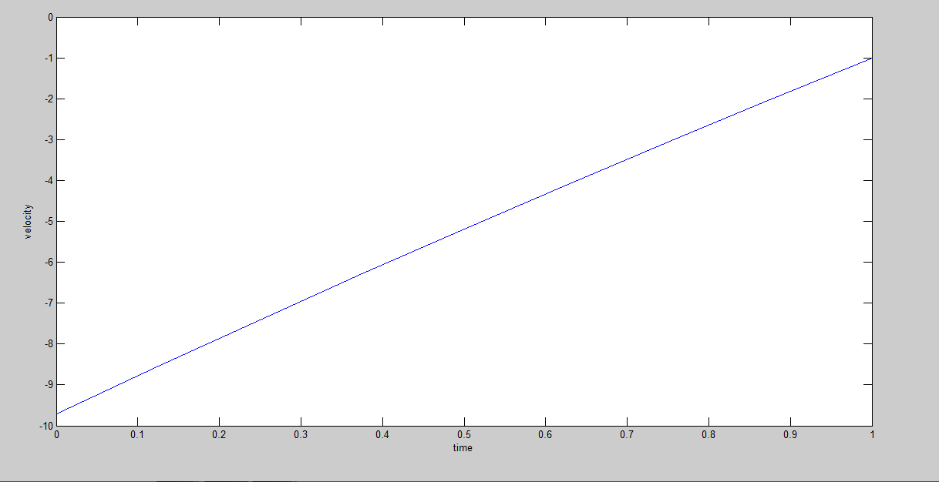

Before the parachute is activated the plot of height against time is as shown below
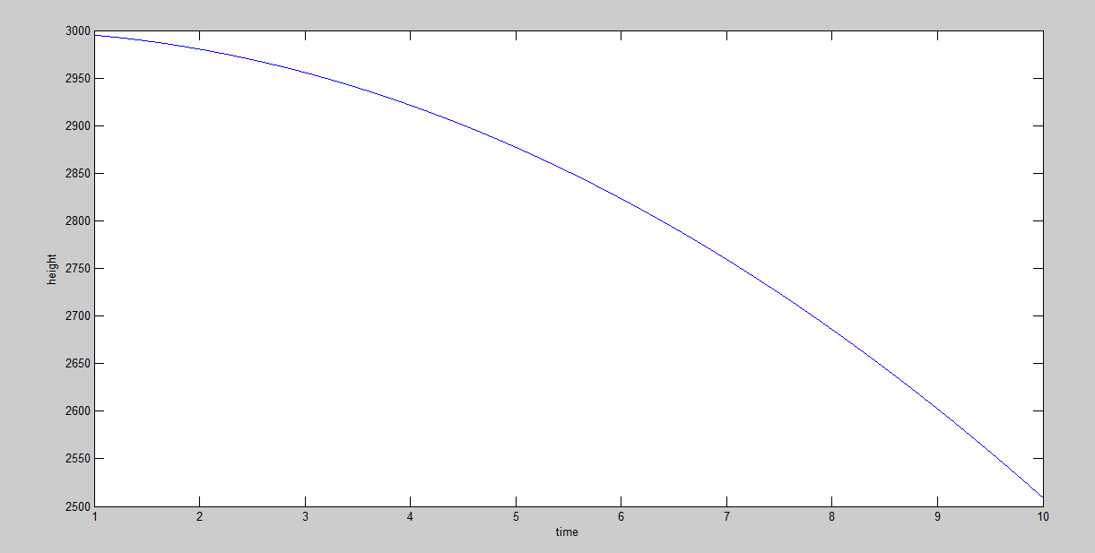

The height decreases due to the influence of gravity
The matlab code is as follows

s0=3000;
g=9.81;
v0=0
t=linspace(1,10,10000)
s=-0.5*g.*t.^2+v0.*t+s0;
plot(t,s)
xlabel('time')
ylabel('height')

After the parachute is activated velocity is as follows
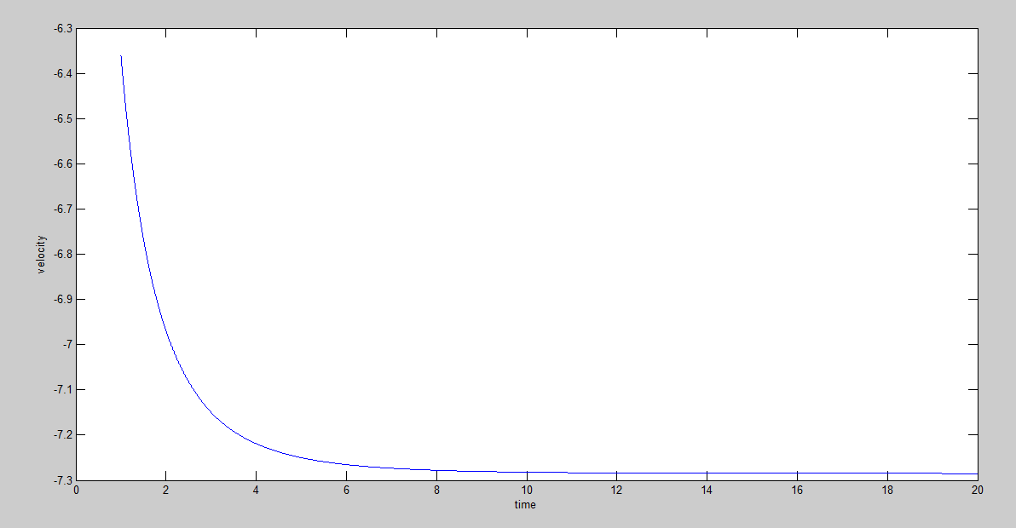

Velocity decreases to zero.
The matlab code for the above graph is as follows:
m=80;
g=9.81;
k=14.7875;
t=linspace(1,20,10000)
v=-sqrt(m*g/k)*tanh(sqrt(k*g*t/m))
plot(t,v)
xlabel('time')
ylabel('velocity')

OVERAL VELOCITY IS AS FOLLOWS
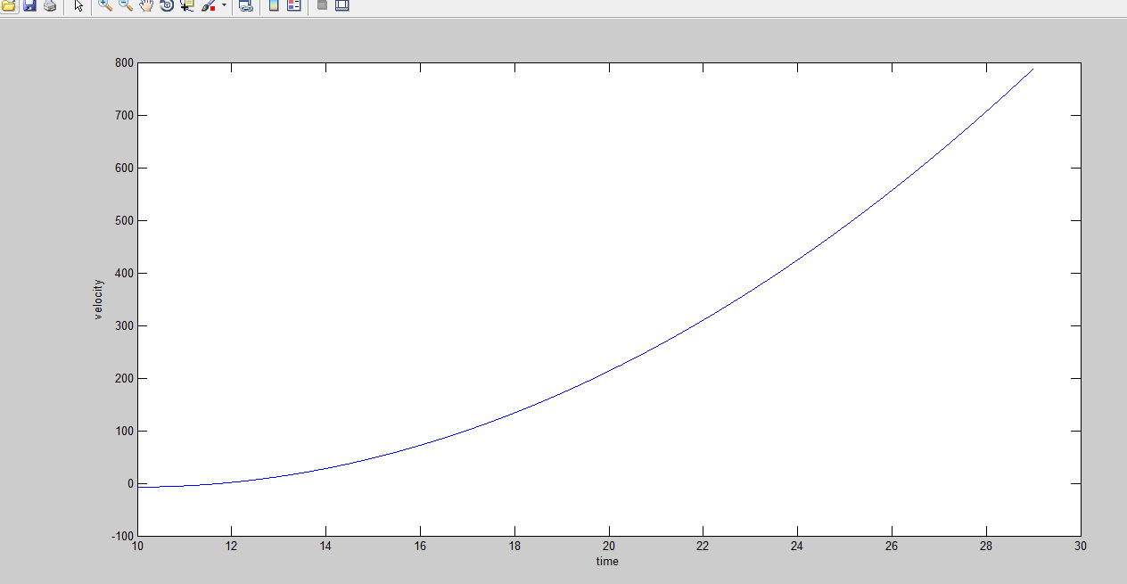

The overall velocity graph.
s01=3000;
s02=s1(10000)
g=9.81;
v01=-1
v02=v1(10000);
s1=-0.5*g.*t1.^2+v0.*t1+s01
a=9.81-(0.00616*t2-0.0616)
s2=-0.5*a.*t2.^2+v02.*t1+s02

%-6.16*10^-7*s2*t2+6.616*10^-6*s2).*v2^2
t1=linspace(0,10,10000);
v1=v01+g*t1;

t2=linspace(10,30,10000);
v2=v02+a.*t2;
s=[s1 s2];
v=[v1 v2];
t=[t1 t2];
plot(t,v);
xlabel('time');
ylabel('velocity');

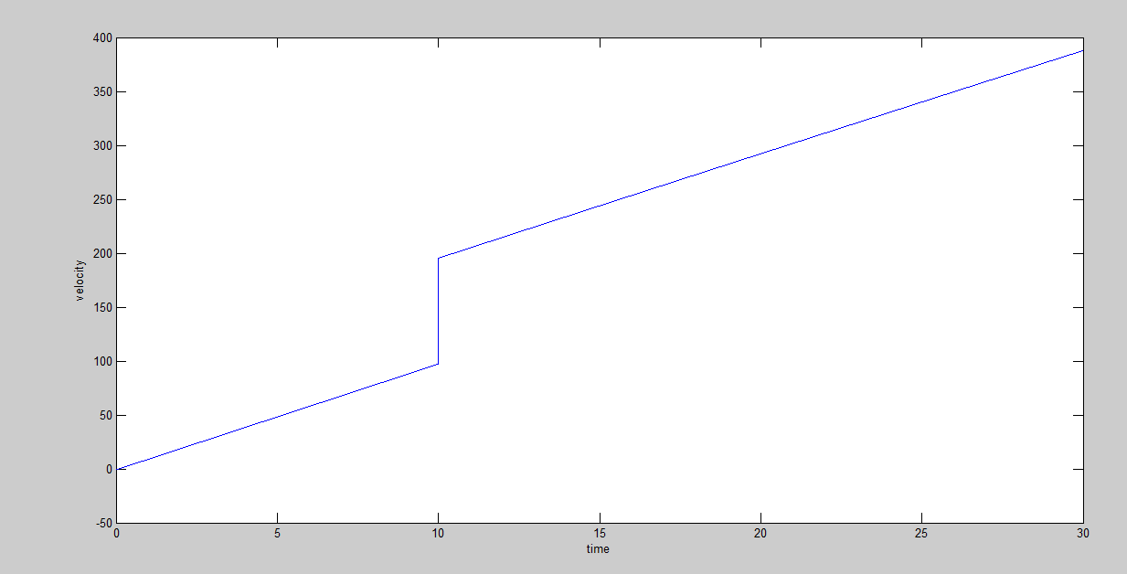

The overall height graph
s01=3000;
s02=s1(10000)
g=9.81;
v01=-1
v02=v1(10000);
s1=-0.5*g.*t1.^2+v0.*t1+s01
a=9.81-(0.00616*t2-0.0616)
s2=-0.5*a.*t2.^2+v02.*t1+s02

%-6.16*10^-7*s2*t2+6.616*10^-6*s2).*v2^2
t1=linspace(0,10,10000);
v1=v01+g*t1;

t2=linspace(10,30,10000);
v2=v02+a.*t2;
s=[s1 s2];
v=[v1 v2];
t=[t1 t2];
plot(t,s);
xlabel('time');
ylabel('height');

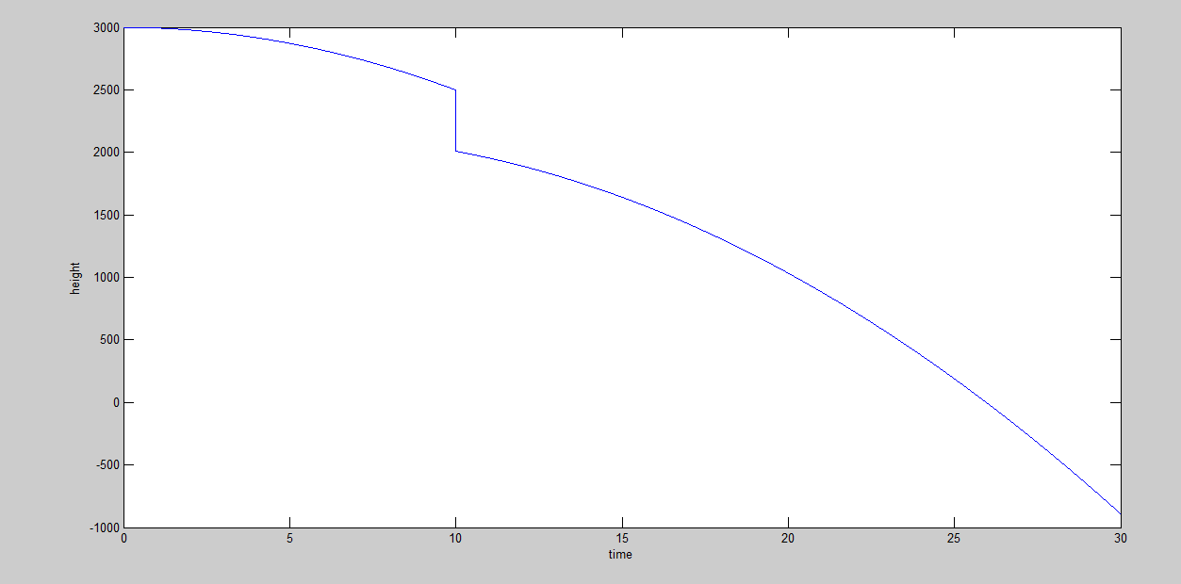

Question 5
The graph of height against time when there is no drag
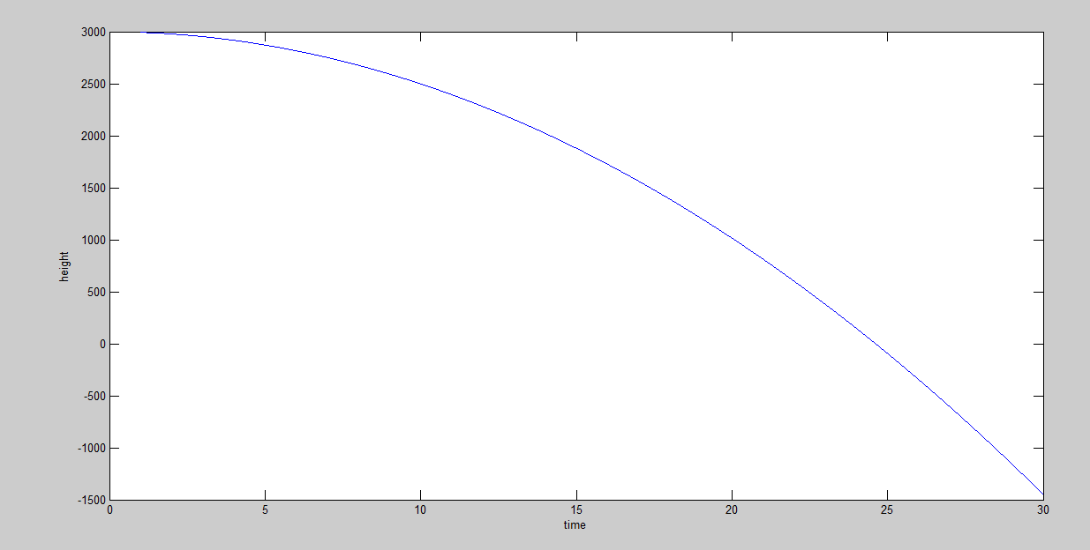

Question 6
Plot of velocity against time for the whole process during free fall.
Matlab code
g=9.81;
v01=-1;
t1=linspace(0,30,10000);
v1=v01+g*t1;
plot(t1,v1);
xlabel('time');
ylabel('velocity');

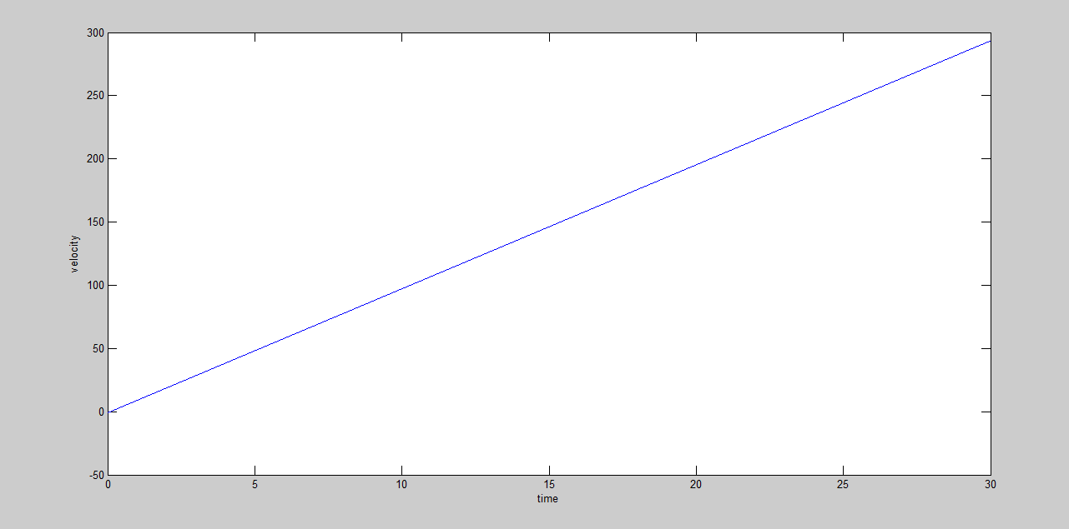

When parachute is included.

There is a deceleration during opening due to the drag force.
Question 7
From the graphs of velocity and height against time,
The landing time when parachute is activated is
25s
Maximum velocity is 400m/s
Question 8
The maximum time is 15s
Question 9
The factors affecting the maximum acceleration are
gravity, the height from which it is launched, the rate of unfolding of the parachute.

